**SHEET METAL TUTORIAL**

**What is sheet metal?**

As its name implies, sheet metal is metal that’s been formed into a thin, flat piece, but it’s also much more than that. Many objects in all facets of life are made from sheet metal, making it the most common form of metal used in metalworking. Applications include kitchen sinks, computers, furniture, cars, trains, airplanes, and much, much more.

Sheet metal is available in every metal we can think of, including stainless steel, aluminium, copper, brass, and even titanium.

With the advancement of CNC machining and cutting, sheet metal parts have become cheaper and easier to make.

**CUTTING**

Sheet metal cutting is always the first step, and it’s important to choose the right method, as this will affect the rest of the design process. If your part is fairly simple and doesn’t include non-circular holes, choose shear cutting, the cheapest and fastest way to cut sheet metal. Of course, this is will only work for metal thinner than 5-6 mm (0.25″).

**DEFORMING**

The next step is usually a deformation. There are a couple ways of getting a three-dimensional object from a flat piece of metal. The two most common are “deep drawing” and bending. With deep drawing, you get complex parts, like car fenders, kitchen pots, or jet engine cowlings. It’s a complex process that requires dedicated tooling, meaning it’s not suitable for a beginner. On the other hand, bending is something everyone can do with relatively inexpensive equipment.

**ASSEMBLY**

The third step is assembly. This can be done with screws and nuts, rivets, or through welding. Every method has its pros and cons, so choose wisely.

After going through the basic steps involved in creating a sheet metal part, let’s take a look at how to actually design sheet metal parts in SolidWorks!

The sheet metal tool allows to quickly create sheet metal part designs using a simple design process, all helping to save time and development costs.

**How to use Solid Works Base flange**

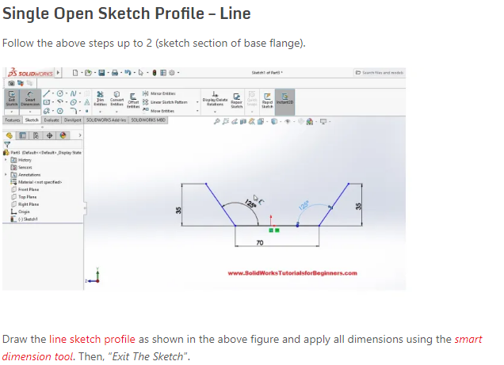

**How to use Solid Works Edge flange**

**How to use Solid Works Miter flange**

Here the miter flange is created on the edges of this part. A face is selected as sketch plane (Condition: sketch plane should be normal to first edge for creating sketch)

**How to use Solid Works Swept flange**

You can create compound bends in sheet metal parts using the **Swept Flange** tool. The **Swept Flange** tool is like the **Sweep** tool; you need a profile and path to create the flange. To create a swept flange, you need an open profile sketch as the profile, and a sketch or a series of existing sheet metal edges as the path.

Any chamfers or fillets on the bend region of the swept flange do not appear in the flat pattern.

For flat patterns, the software calculates a linear calculation. Compression and stretching of the material are not considered.

**Terminologies used**

**K-Factor:**

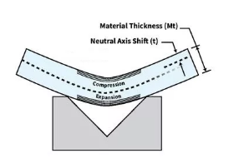

***Figure:1*** *When you bend sheet metal, the neutral axis shifts toward the inside surface of the bend. The K-factor is the ratio of the neutral axis location (t) to the material thickness (Mt).*

**Neutral Axis:**

The neutral axis is a theoretical area lying at 50 percent of the material thickness while unstressed and flat. The neutral axis is a shifty guy; that is, it shifts toward the inside of the bend. The theoretical line of the neutral axis will remain the same length both before and after the bend is complete.

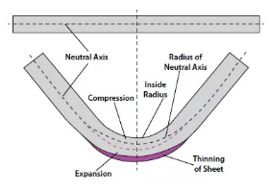

*Figure:2: The thinning sheet forces the neutral axis to shift inward toward the inside bend radius. Describing that shift is what the k-factor is all about.*

**For example:**

1-millimeter (mm) material thickness. In a flat state the material has a neutral axis located at 50 percent of the thickness, at 0.5 mm. Bend the material, and the neutral axis shifts to 0.446 mm, as measured from the inside surface of the bend. We define this neutral axis shift as t, as shown in **Figure 1**. We calculate k-factor by dividing t by the material thickness (Mt): *k-factor = t/Mt,*

The k-factor is nothing more than a multiplier that can give you an accurate value for the relocated neutral axis.

Bending Allowance

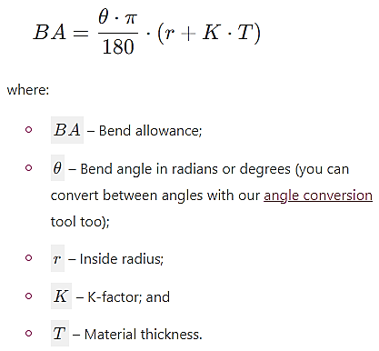

**Bend Allowance Example:**

Say we need to create a bend on a metal sheet with the following properties:

* Bend angle, *θ*=45°; and
* Inside radius, r = 2mm.

And the metal sheet has a thickness T = 5mm and K-factor K = 0.35.

How much material will be needed to create said bend?

We already have all the information we need to calculate it from the bend allowance formula. Using the data as input in our bend allowance calculator, we obtain:

* BA = 2.945mm

Note: For further details of K-factor, bending allowance, types of bends and other terminologies, consult the link below:

<https://www.thefabricator.com/thefabricator/article/bending/k-factors-y-factors-and-press-brake-bending-precision#:~:text=In%20sheet%20metal%2C%20the%20K,expands%20(see%20Figure%201)>

**Exercise**

